Montefiore Antimicrobial Stewardship Program (ASP)

Syndrome Specific Guidelines – Antibiotic Initiation, Adult Inpatients

Notes:
- This document is not intended to replace clinical judgment
- ID assistance recommended for severely ill patients, compromised hosts, pregnancy, organ transplant, etc.
    - Dose and frequency may depend on renal function and weight (e.g. IV vancomycin, gentamicin, acyclovir, SMX/TMP, etc.)
- Always send 8-10cc/ blood cx bottle as part of initial fever work up
- Look at prior micro results to help guide you
- MDRO = multidrug resistant organism
- PCN = penicillin
- Abx = antibiotics
- Recommendations may be amended during drug shortages
- Syndromes are listed in alphabetical order

Take a “time out” at 48-72hrs after starting antibiotics
- Is this antibiotic still needed?
- Can it be narrowed in spectrum or switched to PO?
- How long do I plan to treat?
- Have I obtained appropriate diagnostics and followed up on results?
- Did I document antibiotic plan in the EMR?
- At discharge, did I communicate the correct REMAINING duration of antibiotics to avoid excess use?

Clarifying an Antibiotic Allergy

- Non-IgE mediated penicillin reaction: non-urticarial rash, injection site reaction, unknown/remote reaction (e.g., type IV, delayed hypersensitivity reaction)

- IgE mediated/immediate hypersensitivity reaction: (requires prior drug exposure) urticarial rash, dyspnea, hoarseness, bronchospasm, facial/tongue swelling, anaphylaxis
- 1 in 10 patients report an PCN allergy but 8 in 10 are no longer allergic within a 10-year period
- PCN-cephalosporin cross reactivity rate: ≤ 2.5%; benefit of cephalosporin may outweigh risk
- Take opportunity to challenge while in monitored setting; look back at administered meds from prior admits to see if β-lactam ever given if no reaction, you are good to go!

Colonization vs. True Infection

Colonization may predispose to infection, but does NOT always indicate active infection:

- Asymptomatic pyuria and bacteriuria are common in elderly females and nursing home residents (altered mental status and falls are NOT symptoms of UTI)
- Is the patient symptomatic with signs of active infection? (ex. dysuria, purulent sputum, fever, leukocytosis)
- Are symptoms persistent > 24 hours?
- Is this a condition that may not require abx or only a short course of abx? (ex. tracheitis, aspiration pneumonitis)
- Do radiographs support the presence of infection?
- Was catheter changed on schedule?
- Is there a single dominant organism in culture with many WBC and low epithelial cells?
- Are antibiotics alone likely to cure the infection? Has source control been achieved?
- Can always call ID/ASP for assistance

Aspiration
Obtain CXR, CBC, sputum culture if antibiotics required (aspiration is often caused by chemical irritation, not infectious process; treatment may not be required)

Refer to Montefiore Respiratory Infection Guidelines

Catheter-associated Bloodstream Infection
Send at least 2 sets of blood cultures (culprit line and peripheral blood), remove line and send tip for culture
Treatment
- IV Vancomycin 15-20mg/kg + Cefepime 1-2g +/- Gentamicin 5-7mg/kg IBW x 1 (if sepsis or h/o MDRO);
- If HD OR severe PCN allergy: IV Vancomycin 15-20mg/kg +/- Gentamicin 5mg/kg IV IBW x 1
- *If endocarditis suspected remove line and consult ID, which may recommend cardiology consult for TEE
    - ID consult recommended for Staphylococcus aureus, Candida spp., Pseudomonas spp., and MDROs

Clostridium difficile Infection (CDI)
Obtain CBC, BMP, abdominal Xray or CT if ileus, stool C.difficle, STOP unnecessary PPI, antibiotics, laxatives; Surgery/GI/ID consult recommended for severe or fulminant disease
Access separate Montefiore CDI guidelines at:
https://einsteinmed.edu/uploadedFiles/departments/medicine/Divisions/Infectious_Diseases/Updated%20CDI%20guidelines%202018.pdf
COPD Exacerbation
Refer to MMC Respiratory Infection Guidelines

Community Acquired Pneumonia
Refer to MMC Respiratory Infection Guidelines

Hospital Acquired Pneumonia
Refer to MMC Respiratory Infection Guidelines

Influenza
Obtain Influenza/RSV PCR, SARS-CoV-2 PCR to distinguish between viral syndromes, CXR

Treatment (for patients at risk for severe illness and symptom onset within 72h): Oseltamivir (CrCl ≥ 60 ml/min: 75mg PO Q12h, CrCl 30-59 ml/min: 30mg PO Q12h, CrCl ≤ 29ml/min: 30 mg PO Q24h)

Severe influenza with respiratory failure in an ICU patient: consider ID consult for IV peramivir

COVID-19
Obtain SARS-CoV-2 PCR, CXR, admission labs, and CT thorax as indicated

(https://www.covid19treatmentguidelines.nih.gov/therapeutic-management/)

Treatment of bacterial/fungal co-infection in COVID-19 patients: Refer to separate guidelines on MMC ASP website.

Intra-abdominal Infection (non-CDI):
Community acquired: Ceftriaxone IV 1g + Metronidazole 500mg IV/PO, OR Cefoxitin 1-2g IV/PO +/- Metronidazole 500mg IV/PO, OR Ciprofloxacin 400mg IV/500mg PO + Metronidazole 500mg IV/PO (severe PCN allergy)
- Note: q12h dosing is adequate for most indications (except amoebic infection and C. difficile infection)

Risk for MDROs: Piperacillin/tazobactam 4.5g IV (Aztreonam IV + Metronidazole IV/PO if severe PCN allergy +/- Vancomycin 15-20mg/kg IV for Streptococcal/Enterococcal coverage)

Meningitis/Encephalitis
Obtain LP, blood cultures, CT/MRI; ID consult recommended
Meningitis:
- Age <50 AND normal host immunity: Vancomycin 15-20mg/kg IV + Ceftriaxone 2g IV
- Age >50 OR Immunosuppressed: Vancomycin 15-20mg/kg IV + Ceftriaxone 2g IV + Ampicillin 2g IV

Suspect HSV Encephalitis:
Acyclovir 10 mg/kg IV based on IBW (adjusted body weight for BMI >30); add to meningitis regimen above in at-risk patient if coverage of both meningitis and encephalitis desired

Anaphylaxis to Penicillin:
Vancomycin 15-20mg/kg x IV + [Levofloxacin 750mg IV or Ciprofloxacin 400mg IV]
- If Listeria coverage is needed, add SMX-TMP 5mg/kg q12h

Neutropenic Fever
Look for focal sx/signs on exam and history, blood cultures, UA/UCx, CXR

- Look back at clinical cultures from prior admits to select a targeted antibiotic regimen

Treatment: Cefepime 2g IV

MMC Criteria for adding IV Vancomycin
- Blood cultures positive for GP organisms
- Clinically suspect catheter or skin source (cellulitis, chills with infusion through catheter)
- h/o MRSA or other MDRO infection
- Infiltrate on CXR
- Severe sepsis or hemodynamic instability

Severe illness: Can add Gentamicin 5-7 mg/kg x 1 IV IBW

Severe Penicillin allergy
Aztreonam 1-2g IV +/- Gentamicin 5-7mg/kg IV IBW (enhanced coverage of MDROs) + Vancomycin 15-20mg/kg IV (GP coverage) *for intra-abdominal source, can add metronidazole 500mg IV

Staphylococcus aureus bacteremia:
Remove catheter if present, obtain daily blood cultures, TTE and potentially TEE
- ID consult strongly recommended for assistance with work up, investigation for distant sites of infection, and management (sometimes dual antibiotic therapy required); OPAT follow-up recommended on discharge

Skin & Skin Structure/Bone Joint Infections
Select lower dose for elderly patients or those with low body weight

Syndrome | Regimen
Uncomplicated Cellulitis OR Diabetic Foot Infection  Purulent = S. aureus  Non-purulent, streaky/diffuse = Strep  *Note high local MRSA prevalence in the Bronx | MRSA:  PO: Bactrim 1-2 DS tabs, OR Doxycycline 100mg, OR Clindamycin 600mg  IV: Vancomycin 15-20mg/kg  MSSA:  PO: Dicloxacillin 500mg, OR Cephalexin 500mg, OR Amox/clav 500-875/125mg  IV: Cefazolin 1-2g  Strep:  PO: Cephalexin 500mg, OR Amoxicillin 500mg  IV: Cefazolin 1-2g OR Ampicillin/sulbactam 3g (if anaerobic coverage needed); select lower dose for elderly patients
Severe Soft Tissue OR Complicated Diabetic Foot | (Limb threatening, h/o MDRO or prior abx, toxic appearance)  Vancomycin 15-20mg/kg IV + Piperacillin/tazobactam 4.5g IV
Suspect Necrotizing Infection | Call Surgery/ID consult, add Clindamycin 900mg IV to severe regimen (refine later based on cultures)
Osteomyelitis | Obtain CRP, ESR with routine labs, X-ray (or MRI if inconclusive), OR cultures if possible (superficial wound cultures may not be accurate)  **Consider holding antibiotics to increase bone/tissue culture yield if patient clinically stable and infection is chronic (e.g. chronic diabetic OM)**  Mild to Moderate:  - Ceftriaxone 2g (+/- metronidazole 500mg if necrotic, foul smelling) OR Ampicillin/sulbactam 3g  - +/- Vancomycin 15-20mg/kg (if prior MRSA or excess abx exposure)  Sepsis OR Suspect P. aeruginosa (i.e., foot puncture wound, water exposure, excess abx, past Pseudomonas):  - Piperacillin/tazobactam 4.5g IV OR Cefepime 1-2g IV (+/- metronidazole 500mg if necrotic, foul smelling)  - +/- Vancomycin 15-20mg/kg IV (if high MRSA risk)  Severe Penicillin allergy:  - Aztreonam 1-2g IV OR ciprofloxacin 400mg IV OR levofloxacin 750mg IV  - +/- Vancomycin 15-20mg/kg IV (GP coverage)  - +/- metronidazole 500mg IV if necrotic, foul smelling
Urinary Tract Infection

Change foley, obtain UA/UCx, U/S of kidneys if suspect pyelo or obstruction, BCx if febrile
Cystitis: Cephalexin 500mg PO, OR TMP/SMX 1 DS tab PO, OR Nitrofurantoin 100mg PO (for CrCl >30ml/min), OR Cefdinir 300mg PO, OR Ciprofloxacin 500mg PO (severe PCN and sulfa allergy).
- For urine isolates, cefazolin results predict results for the oral agents cefaclor, cefdinir, cefpodoxime, cefprozil, cefuroxime, and cephalexin when used for therapy of uncomplicated UTI due to E. coli, K. pneumoniae, P. mirabilis

Complicated UTI/pyelonephritis (without h/o MDRO): Ceftriaxone 1g IV
- Anaphylaxis to Penicillin: Gentamicin 3mg/kg IV IBW, OR Aztreonam 1-2g IV, OR Ciprofloxacin 400mg IV or 500mg PO (if from home ONLY)

Severe Illness OR h/o MDRO: Cefepime 1-2g IV +/- Gentamicin 3mg/kg IV IBW x1

Suggested Antibiotic Durations

Syndrome | Median Duration
COPD exacerbation, meets criteria for antibiotics | 3-5 days
CAP | 5 days
Complicated CAP (empyema, bacteremic, S. aureus PNA, abscess, Legionella) | Duration variable up to several weeks  (ID consult recommended);  7-21 days for Legionella based on severity
HAP/VAP (empiric treatment OR isolation of specific pathogen such as MRSA, Pseudomonas, MDRO, etc.) | 7 days
Bacterial meningitis | 7-21 days depending on organism isolated (ID consult recommended)
HSV encephalitis | 14-21 days (ID consult recommended)
Catheter-related bloodstream infection (catheter removal recommended for source control)  For Staph aureus, Pseudomonas, Yeast, and/or recurrent bacteremias – ID consult recommended | CoNS: 5-7 days if transient; longer if persistent  S. aureus: up to 4-6 weeks  GNB (not Pseudomonas): 7-14 days if neg BCx and source controlled  Candida spp.: at least 14 days from first neg BCx; 6 weeks or more for endocarditis
Influenza | Oseltamivir 5 days; up to 7-10 days only if critically ill
Uncomplicated UTI  Pyelonephritis/complex UTI | 3-5 days  7-10 days; ≥14 days if renal abscess (ID consult rec.)
Intra-abdominal source | 4-7 days if source controlled
Skin and soft tissue  (if discrete lesion drained, often no further abx needed) | Pathogen/case specific; 5 to ≥ 14 days  if systemic illness, deep infection, non-healing, unusual pathogen, compromised host – ID and Surgery input suggested
C. difficile colitis | 10 days for first or second episode  See Montefiore C. diff guideline for details
Osteomyelitis | 4-6 weeks depending on source control/hardware; ID consult and OPAT referral recommended
Neutropenic fever  (ID consult suggested) | Hold Abx once afebrile ≥ 48h with negative cultures, resolving neutropenia; if documented source, treat accordingly for site and organism

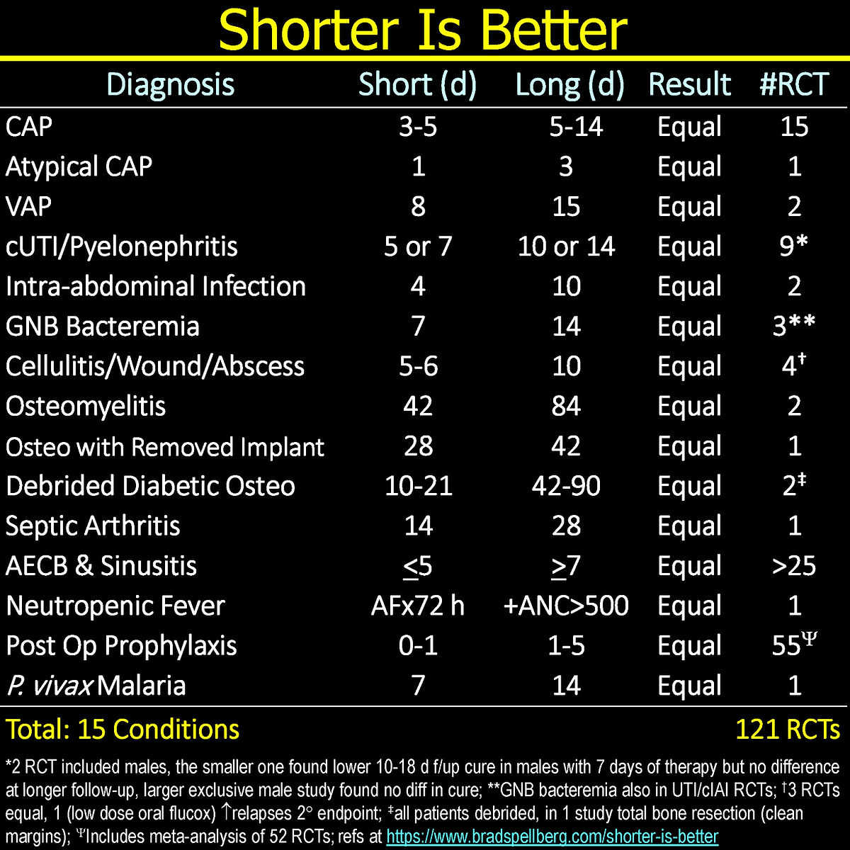

Source:

https://www.bradspellberg.com/shorter-is-better

