New Cayuse Handbook
Cayuse Sponsored Projects (SP) & Cayuse S2S (formerly Cayuse 424.
01/11/2021

Open an internet browser and go to http://Einstein.cayuse424.com
* You will be prompted to enter your Active Directory username and password
Upon logging in, you have the option to access Cayuse SP or Cayuse 424 as shown below.
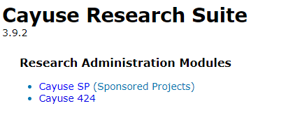
If you use Cayuse SP primarily as a PI or researcher, you can easily create a new proposal from the start page of Cayuse SP. You will be prompted to enter some general information about the proposal before saving it.

Creating a Proposal

Click on My Dashboard, and click on Start New Proposal.
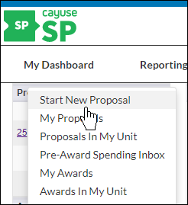
- Fill out Sponsor Information and General Information for your proposal. All fields marked with a red asterisk are required. You can click on for help with locating information for the field.
- Click Save at the bottom of the page.
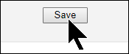

Sponsor Information
- Sponsor (required): This is usually the sponsor whose name will be on the check to the institution, or to whom the central administration office will send invoices. If the sponsor is not listed, contact your system administrator to add a record for the sponsor.
- Funding Opportunity/Sponsor Application Number (optional): Enter the alphanumeric opportunity or sponsor application number. These numbers are generally provided by the sponsor.
- Sponsor Program Name (optional): Enter the program name provided by the sponsor for this proposal.
- Proposal Guideline URL (optional): Enter the website address of the guidelines or instructions associated with the sponsor's application.
- Prime Funding Agency (optional): Enter the name of the prime funding agency if your institution is receiving a subgrant or subcontract from an intermediate source. For example, if NCI awards a grant to Cayuse University, and Cayuse University awards a subgrant to your institution, then NCI would be the prime funding agency.

General Proposal Information
- Admin Unit (required): Select the lead unit that will manage the project.
- Primary Administrative Contact (required): Select the designee who will serve as the contact person for this project during post-award.
- Short Project Name (required): Enter the title used for reference in Cayuse SP. This is equivalent to the proposal name in Cayuse 424 (Continue to use the same naming convention for Short Title)
- Project Start and End Dates (required): Select a start and end date for the project.
- Activity Code (optional): Click to choose the appropriate activity type from the pop-up window. You have the option of choosing Fellowship, Human Subject/ Clinical Trial, Instruction, Other, Other Sponsored Activities/Programs or Research.
- Proposal Type (required):
  - New: Select if you are requesting new dollars NOT associated with an existing contract or grant.
  - Preliminary Proposal: Select if it is a pre-proposal or Letter of Intent.
  - Non-Competing Continuation/Progress Report: Select if requesting release of dollars previously committed by the sponsor for an existing contractor grant.
  - Supplement: Select if requesting additional new dollars, extending period of performance, or requesting a change in the scope of work on an existing award.
  - Resubmission or Amendment: Select if a previously submitted proposal is being reviewed for funding by the sponsor. The submission of a revised request would occur due to revised personnel, cost share, or budget.
  - Revision (Competitive): Select this is s/b for a competitive renewal application/ revision of an existing application. However, select new application if it is a bridge funding application.
  - Renewal (competitive): Select if requesting new dollars for continuation of an existing award to establish a new budget period.
  - Recurring Contract: Select this if it is a renewing contract, extending a contract to a new budget period.
- Instrument Type (required): Select from Grant (Federal/Non-Federal), Contract, Cooperative Agreement, Fellowship, Human Subject/ Clinical Trial, Incoming Subcontract, or Other Grant.
  - If Grant (Federal/Non-Federal), select from the following Sub-Instrument Types: R01, Other R-Series, T-Series, K-Series, F-Series, U-Series, P-Series, Other, S-Series.
- How will this proposal be submitted? (optional): Select the submission method for the proposal. Choose one of the following: Cayuse 424, Grants.gov forms, research.gov, Sponsor website, Email, Paper, Other, or eRA Commons. Paper submissions will require you to enter number of copies required, sponsor's mailing address, and contact phone number.
- Affiliated Units (optional): Leave blank. All affiliated units should be added at the approving units rather than affiliated units.
- Sponsor Deadline (required): Enter the date by which the proposal must be postmarked or received by the sponsor.
- Title of Project (required): Enter the full title of the proposal that is being submitted to the funding agency. This title should match the title on the cover letter, face page, and abstract to the sponsor.

Pairing with an Existing Proposal
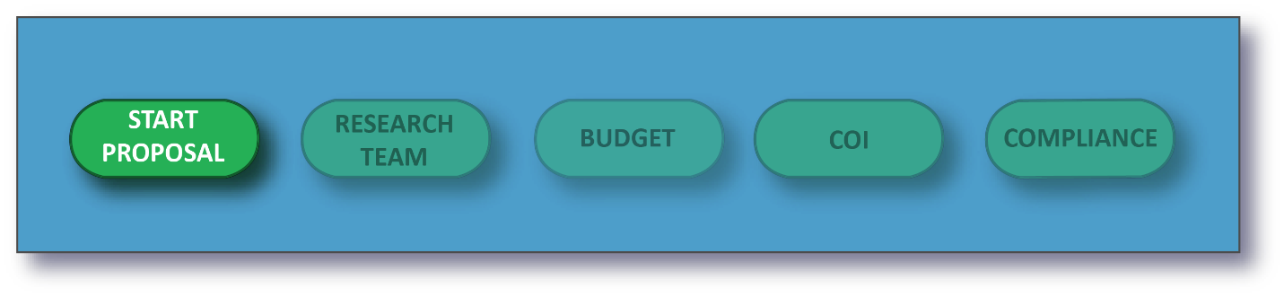
Upon filling out General and Sponsor Information when creating your proposal, you will see an option to pair your Cayuse SP proposal with a Cayuse 424 proposal. During proposal creation, only one of these options is active: Create a Paired Proposal. Upon saving this page, Pair with a 424 Proposal will also be active.
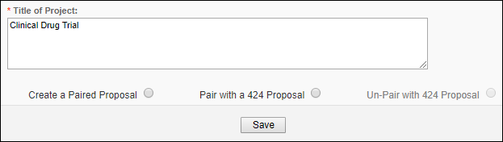
We recommend building your proposal in Cayuse SP, but proposals can also be paired after creation.
When the proposals are linked, routing in Cayuse 424 is turned off and handled through Cayuse SP. If the proposal is a federal proposal, the Cayuse 424 proposal will be the proposal submitted to Grants.gov.

Creating a New Paired Proposal
- Once you have filled out all the basic information required to create your proposal, click Create a Paired Proposal.
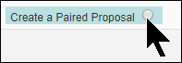
- Depending on your settings, Cayuse 424 will open in a new window or tab, and the Create Proposal dialog box will pop up.
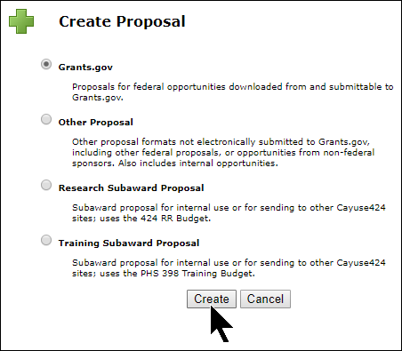
- The Cayuse SP Proposal's Short Project Name becomes the Cayuse 424 proposal's Proposal Name, and the Sponsor Deadline is the Due Date. This information is carried over from Cayuse SP for your convenience, and you can change it as you would for any Cayuse 424 proposal. This will not affect the linkage between the proposals.
- Follow the steps for creating a Cayuse 424 proposal.
Once you have completed the proposal creation in Cayuse 424, you'll see your newly-created proposal with next to the proposal name at the top . Clicking on the icon will direct you back to Cayuse SP.

Pairing an Existing Cayuse 424 Proposal
- If you know that there is already an existing Cayuse 424 proposal for your Cayuse SP proposal, click Pair with a Cayuse 424 Proposal after saving the General Information page.
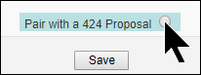

- A dialogue window will show you a list of 424 proposals that you can pair with. Click on the proposal you want to link.
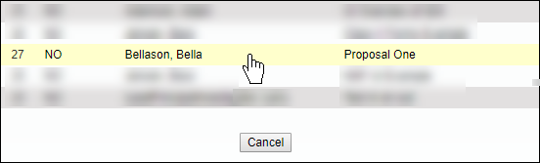
You will now be able to access the 424 proposal by clicking on Cayuse 424 Proposal in the side menu.
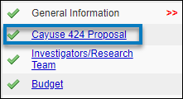
Investigators/Research Team: Please enter all Key Personnel and their effort on this proposal. When completing this section, please note that key personnel must list some effort on this proposal.
Budget:
- All applications require a detailed (RR) budget. If the proposal is for more than one year, you must supply a detailed budget for each year.
- If (R01) budget is greater than $500,000 direct cost, net of subcontract indirect cost, in any year, please get prior approval from the NIH
- For general budget guidance, contact the Office of Grant Support (either Gerard Mcmorrow or Dhanonjoy Saha OGS@Einsteinmed.edu)
- For Human Subject Research/Clinical Trials with a clinical cost component you must contact the Office of Clinical Trials to make sure all components are budgeted (OCT@Montefiore.org)
- If using a Single IRB (incoming or outgoing) , you must contact Office of Human Research Affairs (SingleIRB@Einsteinmed.edu) for all other IRB related questions, please contact EInstein IRB (IRB@Einsteinmed.edu)
- Have you remembered to include the following?
  - Other Admin Human Subject Costs
  - Patient Related Costs
  - Facilities Costs
- Budgeted salaries of named personnel should use the individual’s current base salary plus an increment of up to 3% for each year of the budget. Any variance should be noted. If the salary reflects an expected promotion or raise or the person is to be hired, attach documentation.
  - If the person is on Montefiore Payroll, note this and include MMC ORSP on the routing chain.
  - If the person is on Yeshiva University or Jacobi Hospital Payroll, provide documentation of the salary
- The NIH salary cap (currently $212,100 per annum) only applies to NIH, some other Federal agencies (excluding DOD) and other grantors that specifically mandate it. Please be sure to note it and attach documentation from other grantors if they mandate the NIH salary cap or any similar cap.
- If an incoming or outgoing subcontract is included, a detailed RR budget must be completed.
- If the modular budget format is used, a detailed RR budget must be included for all years. The direct cost, indirect cost and total cost of the RR budget must exactly match the relevant modular amounts each year.
- Indirect cost should follow the NIH negotiated rate schedule. Otherwise, explain and include documentation from the grantor of a lower rate as an attachment. The Einstein F&A Policy must also be adhered to.

Conflict of Interest: The questions in this section are required to help identify whether members of the Research Team, their family members, or the institution are involved in activities that may impose an actual or perceived conflict of interest as it would relate to the conduct of the research or a member's relationship with the funding agency.

Regulatory Compliance: To ensure required regulatory and institutional approval, please complete this section for Human Subjects, Animal Subjects and Research Materials.

Subcontract: If no subcontracts are proposed, please click the No Subcontractors button to complete this section. If this proposal involves subcontractors (for which funds are requested), please add them below by typing the subcontractor's name into the text field and clicking "Search”.
Export Control: Please complete this section.

Intellectual Property: The Office of Biotechnology and Business Development leads the commercialization and intellectual property protection matters for Einstein. Einstein retains assignment of all patents granted to its faculty. The college, through its Patent Committee, provides a mechanism for internal peer review and encouragement for its faculty to pursue patenting of technologies that are novel and have commercial applications in biology and medicine. These applications have broad utility in biotechnology, clinical diagnostics and pharmaceutical medicine. The college is interested in promoting industry-sponsored research on our campus and the commercial development of products derived from our research activities.

Location: Please indicate the locations where your research will occur and assign a percentage to each location. Percentages should reflect the portion of the total budget that will be expended in that location: Note: If activities occur on Campus, do not add the country as a separate In-State location. Likewise, for the state and county.
NOTE: You must click the Add Button (functions as save)

Proposal Attachments
The most common documents to be attached to Cayuse are:
1. Budget Justification
2. Documents for Central Administration signature
3. Consortium page or Statement of Intent
4. Indirect Cost/F&A limit

Under certain circumstances the following documents will be needed:
1. IACUC Grant Application Page
2. Animal Use Assurance Statement (AA-1 Form)
3. RFA
4. Other Grantor Guidelines
5. Salary Cap Info
6. Single IRB Reliance Support Letter
NOTE: if you do not have any attachments, you must select


Approving Units: It is the PI’s responsibility to ensure that all required institutional reviews and approvals are issued prior to submission of this grant application.
- The routing chain is a string of units and individuals who need to approve a proposal. The Admin unit is always the first on the routing chain. Other units will be added when:
• a person in a unit is added to the research team as a key participant.
• the unit is a parent of the unit that has been added.
- Units can be added manually if a unit has an interest in the proposal. You may need to add any/all of the displayed units based on your proposal.
  - NOTE: If you add a unit in error, you can remove the unit.
- All departments have two units. The “Z” units were created to allow administrators to add him/herself to the end of the routing chain. Please see the below example:
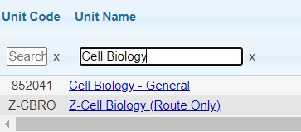
- Parallel Routing is enabled so that many of the approvals IRB, OCT, IACUC can occur simultaneously. Build your routing order in column 1 below. You can use the same number for multiple department approvals. If you do so, those with the same number will route for approval simultaneously. (The routing chain works in tiers, 1 has to approve, then its routed to all 2s, once all 2s approve its routed to 3s and so on)
• Einstein IRB | • Environmental Health and Safety
• Conflict of Interest Office | • Animal Institute IACUC
• Montefiore Office of Clinical Trials | • Montefiore ORSP
• Office of General Counsel | • Office of Biotechnology & Business Development
• Core Facilities
Submission Notes: Please let us know of any special instructions reflect to this proposal such as waiver or reduced F&A, no salary requests, delayed onset human subject research, budgeted salary varies from current salary, or if any named personnel on the Montefiore payroll.
Submitting a Proposal for Routing
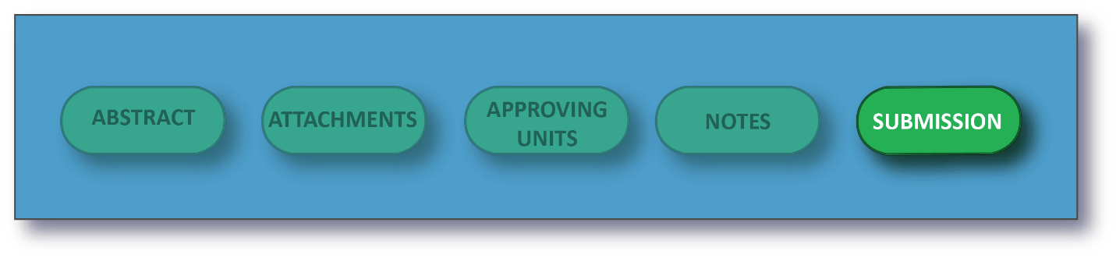
The proposal creator or any member of the Research Team can submit a proposal record for routing in Cayuse SP. A proposal record can only be routed when all sections in the Item List have green check marks. This does not apply to the Submission Notes section.
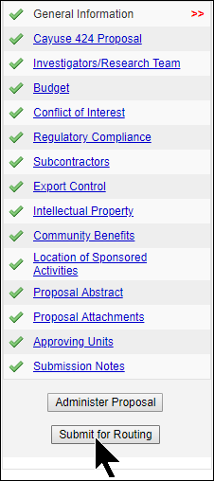

How to Submit a Proposal for Routing
- Click My Proposals on the Proposal Dashboard.
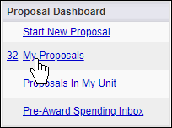
- On the Unsubmitted Proposals tab, click the proposal number that is ready to be routed.
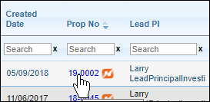
- Click beneath the Item List on the left side of the screen. If you get an error when you click this button, the proposal cannot be routed yet. Check the Item List and complete the necessary sections.

- Read the Submission Confirmation statement to understand what will happen when the proposal record is submitted for routing. Click to acknowledge the submission certification.
If you need to make changes to the proposal after submitting it for routing, you can ask a Cayuse SP System Administrator to change the proposal back to the Unsubmitted status, or you can ask the first unit approver to reject it, which will reopen the proposal. Reopened is similar to Unsubmitted in that you will be able to edit the proposal while it is Reopened.

If you are a Principal Investigator on a proposal, you can certify the proposal once it has been submitted for routing. In Cayuse SP, the Lead PI and other Principal Investigators have the authority to certify.
You will know if you have any proposals awaiting certification if you see a number next to the PI Certification Inbox.
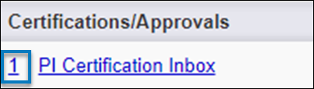
You will also be notified via email when a proposal is in need of certification.

Certifying a Proposal
- In the left-hand menu, click on PI Certification Inbox.
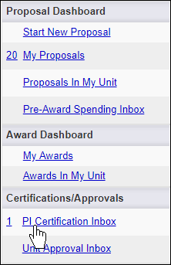

- Beneath the To be Certified tab, click on the proposal number of the proposal you need to certify.
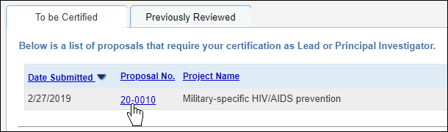
- Review the proposal by clicking on the PDF icon or proposal number.
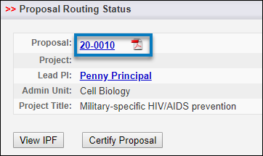
- After you have reviewed the proposal, click on Certify Proposal beneath the Item List or on the Proposal Routing Status screen.
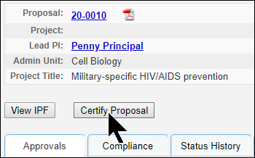
- Enter comments you have regarding the proposal (required). These will be visible to the Research Team, proposal reviewers, and the Central Admin Office.

- Click Submit Certification to acknowledge the certification statement.
IPF Approvers (Deans, Chairs, Directors, or their designees) are notified via an automatic email when a proposal record requires authorization. Units within an institution must authorize in the routing order specified on the proposal record.
Only one authorization is required at each level. After all units have authorized, the proposal record is assigned to the Central Admin Office for review.
NOTE: If the PI prefers to approve outside the Cayuse System. The Administrator can populate the PI Certification Form, obtain his/her signature and upload as an attachment in Cayuse SP.
Authorizing or Rejecting a Proposal
- Review the proposal.
- At the bottom of the proposal menu, click Authorize Proposal or Reject Proposal on the Proposal Routing Status screen.
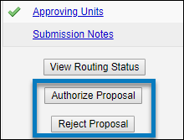
- Enter any comments you have regarding the proposal. This field is required. Your comments will be visible to the Research Team, proposal reviewers, and the Central Admin Office.
- Click Submit Authorization or Submit Rejection to acknowledge the authorization statement.
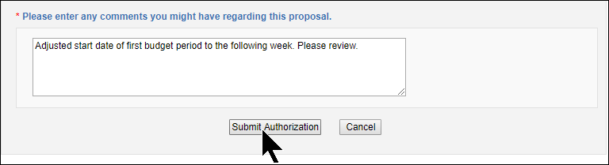
When you reject a proposal, it receives the status Reopened, and the Research team and creator will be able to edit it and resubmit it for routing.
If you authorize the proposal, the next Approver will receive an email notifying them that they need to review the proposal.

